1.Brief about SplitMAC architecture and how it improves the AP's performance
SplitMAC architecture is a design used in wireless networks where the functions of an Access Point (AP) are divided into two parts instead of being handled completely by the AP itself.
Normally, an AP does everything — like handling wireless signals, managing connections, security, and data processing. But in SplitMAC architecture, these tasks are split between,
- Access Point (AP): Handles basic tasks like sending and receiving wireless signals (low-level functions).
- Wireless LAN Controller (WLC): Handles complex tasks like authentication, security, traffic management, and decision-making (high-level functions).
So, instead of each AP working independently, many APs are controlled centrally by a controller.
SplitMAC architecture improves the performance of an Access Point (AP) by reducing the amount of work it has to do. Instead of handling everything on its own, the AP only takes care of basic tasks like sending and receiving wireless signals, while more complex tasks such as security, authentication, and traffic management are handled by a central controller. This makes the AP faster and more efficient because it is not overloaded. It also helps in managing multiple APs easily from one place, ensuring better coordination and smoother user experience. As a result, users get more stable connections, less network congestion, and seamless movement between different APs without interruptions.
2. Describe about CAPWAP, explain the flow between AP and Controller.
CAPWAP (Control and Provisioning of Wireless Access Points) is a protocol used in wireless networks to connect Lightweight Access Points (APs) with a Wireless LAN Controller (WLC). It allows the controller to centrally manage multiple APs, making the network easier to control, configure, and maintain.
When an Access Point is powered on, it follows a series of steps to connect with the controller:
First, the AP needs an IP address. It uses the DHCP process, where it sends a request and receives an IP address from the DHCP server. Once it gets the IP address, the AP starts searching for the controller. This step is called controller discovery, where the AP sends a discovery request and the controller responds.
After finding the controller, a secure connection is established using DTLS encryption. This ensures that all communication between the AP and the controller is protected.
Next, the AP sends a join request to the controller. If accepted, the controller sends a join response, and the AP becomes part of the network. If required, the controller may also send a software image update to ensure the AP is running the correct version.
Once the AP joins successfully, the controller sends the configuration details, such as network name (SSID), security settings, and policies. The AP applies these settings and becomes ready to serve users.
To maintain the connection, both the AP and controller continuously exchange keepalive and echo messages. This ensures that the connection is active and working properly. If any changes are made in the network, the controller sends configuration updates, which are automatically applied by the AP.

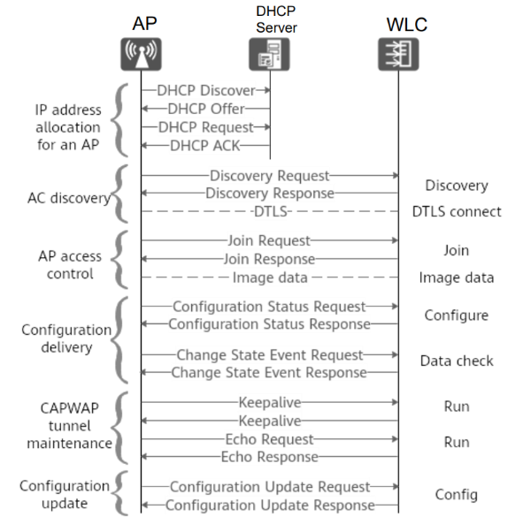
3. Where this CAPWAP fits in OSI model, what are the two tunnels in CAPWAP and its purpose.
CAPWAP mainly operates at the Application Layer (Layer 7) of the OSI model, because it is responsible for communication, control, and management between the Access Point (AP) and the Wireless LAN Controller (WLC). However, it also makes use of lower layers for actual data transmission. For example, CAPWAP uses UDP at the Transport Layer (Layer 4) for sending packets, and IP at the Network Layer (Layer 3) for addressing and routing. So, even though it is primarily considered an application-layer protocol, it depends on the lower layers to function properly.
CAPWAP creates two separate logical tunnels between the AP and the controller to handle different types of communication:
1. Control Tunnel
This tunnel is used for exchanging control and management information between the AP and the controller. It carries messages related to configuration, authentication, software updates, and monitoring. This tunnel is secured using encryption (DTLS), ensuring safe communication.
Purpose:
To manage and control the AP remotely from the controller in a secure and efficient way.
2. Data Tunnel
This tunnel is used to carry actual user data, such as internet traffic from wireless clients. The AP collects data from connected devices and sends it through this tunnel to the controller for processing and forwarding.
Purpose:
To transport user data between the AP and controller efficiently, enabling centralized data handling.
4. Whats the difference between Lightweight APs and Cloud-based Aps
Feature | Lightweight AP | Cloud-Based AP
Controller Location | Local (on-premise WLC) | Remote (cloud over internet)
Management | Managed by physical controller in network | Managed through cloud dashboard
Deployment | Requires controller setup | Easy to deploy, no hardware controller needed
Cost | Higher (needs controller hardware) | Lower (no extra hardware required)
Accessibility | Limited to local network | Can be accessed from anywhere
Scalability | Moderate (depends on controller capacity) | High (easily scalable via cloud)
Maintenance | Manual updates and maintenance required | Automatic updates via cloud
Usage | Large enterprises, campuses | Small to medium businesses, remote setups
5. How the CAPWAP tunnel is maintained between AP and controller.
The CAPWAP tunnel between the Access Point (AP) and the Wireless LAN Controller (WLC) is maintained through continuous communication and monitoring. Once the tunnel is established, the AP and controller regularly exchange keep-alive messages (heartbeat messages) to ensure that the connection is still active. If these messages are not received within a certain time, the system assumes that the connection is lost. The tunnel is also secured using DTLS (encryption), which keeps the communication safe from unauthorized access. In addition, the controller continuously manages and updates the AP by sending configuration changes, while the AP sends status updates and client information back to the controller. If any interruption occurs, the AP automatically tries to re-establish the connection by rediscovering and reconnecting to the controller. This continuous exchange of messages and automatic recovery mechanism helps in maintaining a stable, secure, and reliable CAPWAP tunnel.
6. Whats the difference between Sniffer and monitor mode, use case for each mode
Sniffer mode and monitor mode are both used to observe network traffic, but they work in slightly different ways and are used for different purposes.
A sniffer mode (also called normal packet capture mode) is used to capture and analyze data packets that are already part of a network. In this mode, the device is connected to a network and can only see the traffic that is sent to it or passing through it. It is commonly used for troubleshooting, performance monitoring, and analyzing network issues.
On the other hand, monitor mode is a special mode used mainly in wireless networks. In this mode, the device can capture all wireless traffic in the air, even if it is not connected to any network. It allows the system to see raw packets, including management and control frames, which are normally hidden. This makes monitor mode very useful for advanced analysis and security testing.

Use Cases
Sniffer Mode Use Case:
Sniffer mode is mainly used by network administrators to monitor network performance, detect errors, and troubleshoot issues such as slow connections or packet loss within a connected network.
Monitor Mode Use Case:
Monitor mode is used for wireless network analysis, such as checking signal strength, analyzing Wi-Fi traffic, detecting unauthorized devices, and performing security assessments.
7.If WLC deployed in WAN, which AP mode is best for local network and how?
When a Wireless LAN Controller (WLC) is deployed over a WAN, the best AP mode to use for the local network is FlexConnect mode. In this situation, the Access Point (AP) is placed at a remote location, while the controller is located far away, such as in a central office. If a normal mode is used, all the user data has to travel through the WAN to reach the controller, which can slow down the network and increase bandwidth usage.
FlexConnect mode solves this problem by allowing the AP to handle user traffic locally. This means that activities like browsing the internet or accessing local resources happen directly within the local network without sending all the data to the controller. At the same time, the AP still connects to the controller for configuration, monitoring, and updates.
Another important advantage is that even if the WAN connection fails, the AP can still continue to provide basic network access using its stored settings. Because of these benefits, FlexConnect mode is the most suitable choice when the controller is deployed over a WAN.
8.What are challenges if deploying autonomous APs (more than 50) in large network like
One major challenge is difficult management. Updating settings, security policies, or firmware on each AP individually becomes complex and inefficient, especially as the network grows. Another issue is lack of coordination between APs. Without centralized control, APs cannot automatically adjust channels or power levels, which can lead to interference, poor signal quality, and reduced performance.
Security management is also harder, as ensuring consistent security settings across all APs is difficult. This can create vulnerabilities in the network. Additionally, roaming experience for users may not be smooth, since autonomous APs do not efficiently handle seamless handoffs when users move between different coverage areas.
Troubleshooting is another challenge, as network administrators must check each AP separately to identify problems, which takes more time. Overall, managing a large number of autonomous APs becomes complex, less efficient, and harder to scale compared to centralized solutions.
9. What happens on wireless client connected to Lightweight AP in local mode if WLC goes down.
When a wireless client is connected to a Lightweight Access Point (AP) operating in local mode, the AP depends completely on the Wireless LAN Controller (WLC) to manage and forward traffic. If the WLC goes down, the AP loses its connection to the controller, which means it can no longer properly handle client communication.
As a result, the AP usually stops serving clients. Existing clients may get disconnected, and new clients will not be able to connect. Even if a device appears to stay connected for a short time, it will not be able to access network resources like the internet because all data traffic is normally sent through the controller.
In simple terms, since the AP relies fully on the controller in local mode, the failure of the WLC leads to loss of connectivity for users. The network will only return to normal once the controller is back online or the AP reconnects to another available controller.

